Assignment No. 1

梁鑫宇3160104494

Objectives

This assignment has been designed so that you understand the concept of classes in C++. After the completion of this assignment you should have a good grasp on:

- Writing classes in C++.
- Accessing the data members of the class, using member functions.
- Writing constructor and destructor.

Source Code

class Opt_library.h
class Opt_library
{
private:
int card_number;
int valid_days_left;
int books_issued;
int books_returned;
int Number_of_books;
public:
Opt_library(int,int,int,int);
~Opt_library();

int getCardNumber(){return card_number;}
int getValidDaysLeft(){return valid_days_left;}
int getBooksIssued(){return books_issued;}
int getBooksReturned(){return books_returned;}
int getNumberOfBooks(){return Number_of_books;}
void setCardNumber(int id){card_number = id;}
void setValidDaysLeft(int days){valid_days_left = days;}
void setBooksIssued(int issued){books_issued = issued;}
void setBooksReturned(int returned){books_returned = returned;}
void setNumberOfBooks(int books){Number_of_books = books;}

int PreviousStatusOfTheCard();
int issue_books(int);
void display();
};

Opt_library function.cpp
#include"class Opt_library.h"
#include<iostream>
using namespace std;

Opt_library::Opt_library(int id,int days,int issued,int returned)
{
card_number = id;
valid_days_left = days;
books_issued = issued;
books_returned = returned;
}

Opt_library::~Opt_library()
{
cout << endl << "Destructing..." << endl;
}

int Opt_library::PreviousStatusOfTheCard()
{
if(books_issued > books_returned)
{
cout << endl << "No further operations can be made. Some books are still not returned" << endl;
cout << endl;
return 1;
}
else if (books_issued == books_returned)
{
cout << endl;
cout << "Card Number: " << card_number << endl;
cout << "Valid days left: " << valid_days_left << endl;
cout << "Books issued previously: " << books_issued << endl;
cout << "Books returned previously: " << books_returned << endl;
cout << endl << " " << "The status has been cleared." << endl;
cout << endl;
return 0;
}
}

int Opt_library::issue_books(int books)
{
if(valid_days_left < 15)
{
cout << endl << "Books cannot be issued, there are not enough days left for the validity of card" << endl;
cout << endl;
return 0;
}

if(books > 2)
{
cout << endl << " " << "More than 2 books can not be issued at a time" << endl;
cout << endl;
return 1;
}

if(books <=2 && valid_days_left >= 15)
{
Number_of_books = books;
display();
return 0;
}

}

void Opt_library::display()
{
cout << endl << Number_of_books << " book(s), issued to the " << card_number << endl;
}

main.cpp
#include <iostream>
using namespace std;
#include"class Opt_library.h"

int main(int argc, char** argv) {
int id, days, issued, returned, books;

cout << "Enter card number: ";
cin >> id;

cout << "Enter days left for the validation: ";
cin >> days;

cout << "Enter number of books issued previously: ";
cin >> issued;
while(issued < 0)
{
cout << endl << "Number of books issued can not be negative" << endl;
cout << "Enter number of books issued previously: ";
cin >> issued;
}

cout << "Enter number of books returned previously: ";
cin >> returned;
while(returned < 0)
{
cout << endl << "Number of books returned can not be negative" << endl;
cout << "Enter number of books returned previously: ";
cin >> returned;
}

while(issued < returned)
{
cout << endl << "Number of books returned can not be greater than number of books issued" << endl;
cout << endl;
cout << "Enter number of books issued previously: ";
cin >> issued;
cout << "Enter number of books returned previously: ";
cin >> returned;
}

Opt_library op(id, days, issued, returned);
int flag1 = op.PreviousStatusOfTheCard();
if(flag1)
{
return 0;
}

cout << "Please enter the number of books to be issued: ";
cin >> books;

int flag2 = op.issue_books(books);
while(flag2)
{
cout << "Please enter the number of books to be issued: ";
cin >> books;
flag2 = op.issue_books(books);
}

return 0;
}

Test

Test 1: when user enters 2 books to be issued
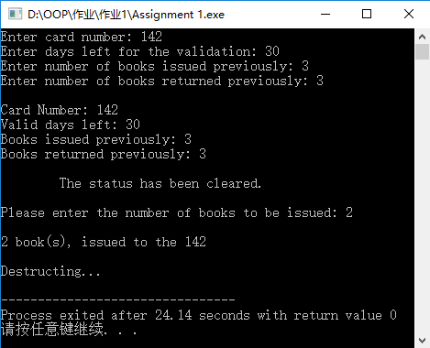

Test 2: when user enters more than 2 books to be issued
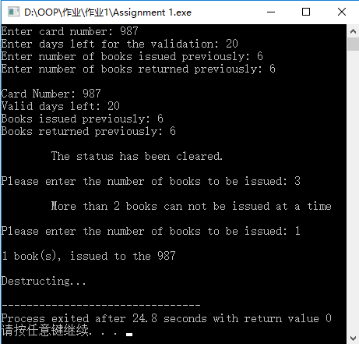

Test 3: when some books issued previously, have not been returned
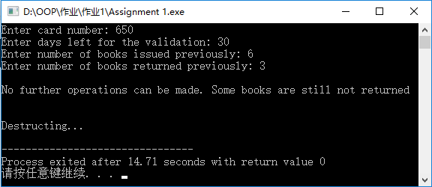

Test 4: when the days left for the validity of card are not enough
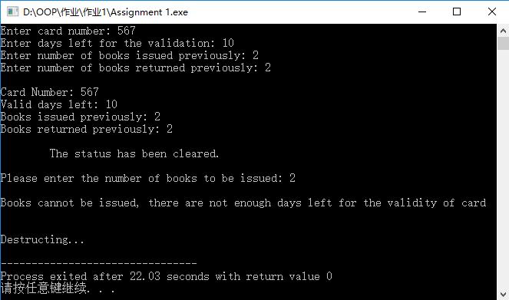

Test 5: when the user enters books_returned which are more than books_issued

